April Newsletter:
- Pictures from the March team
- Last call for June 16-24 team
- Salary support needed for school and clinic staff.
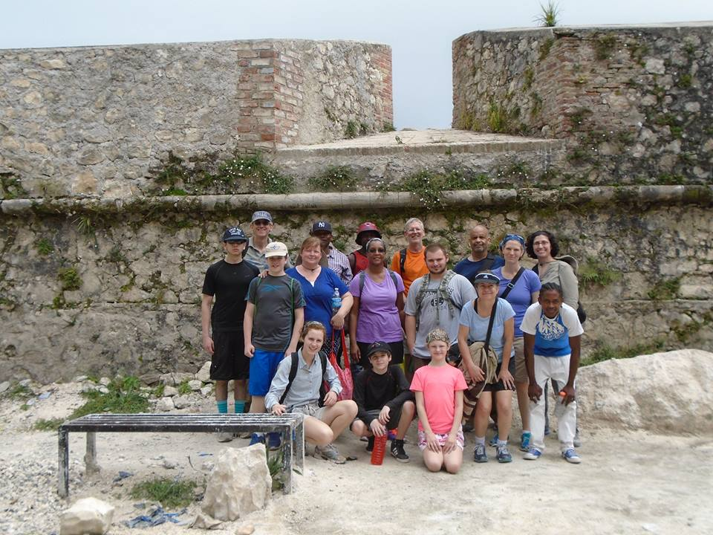
The Team at Fort Jacques.

The week following Easter Sunday the IOG had a team from Silver Spring UMC in Merger for the week. Thirteen people spent time with the children and teachers of Ecole Guerny Filostin, helped with construction projects helping Miracia Hospital prepare for increased operations, and toured Fort Jacque and the Baptist Mission, learning more about the history and people of Haiti. Their fundraising efforts enabled us to hire three teams of workers for digging the new cistern, while others painted and hauled block and rebar and worked on other projects. We also hosted two days of pastor seminar for about 30 pastors in the area. Rev. Rachel Cornwell and I led sessions in sermon preparation and delivery and care for persons in times of grief. The team had some of the youngest members that we have hosted at 12 and 13 years old.

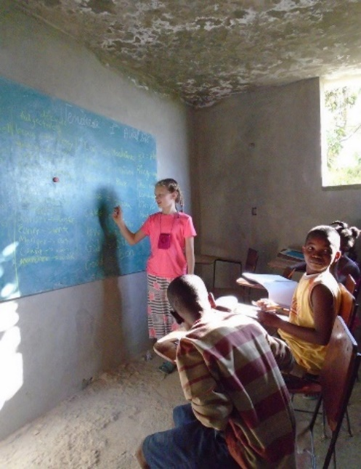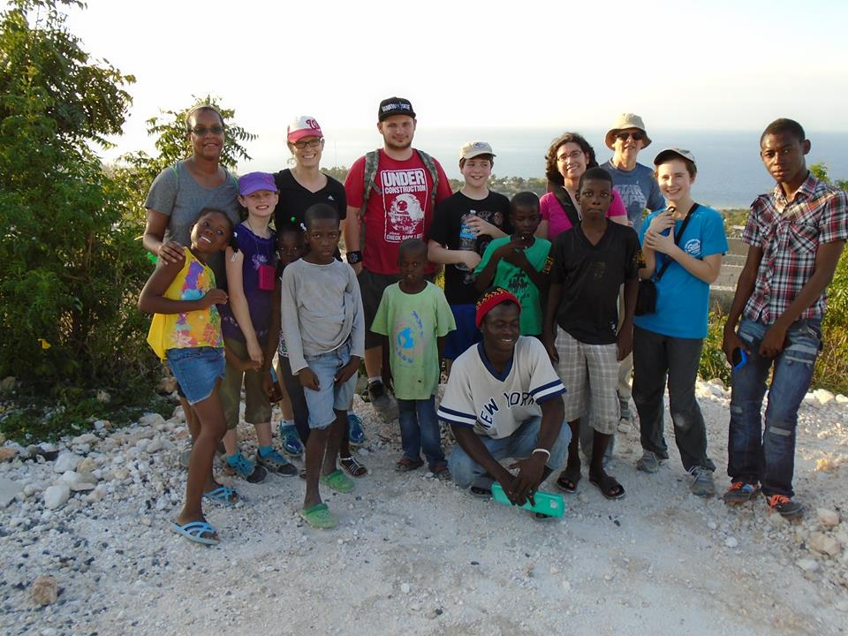
Teaching class. A hike up the hill with friends.
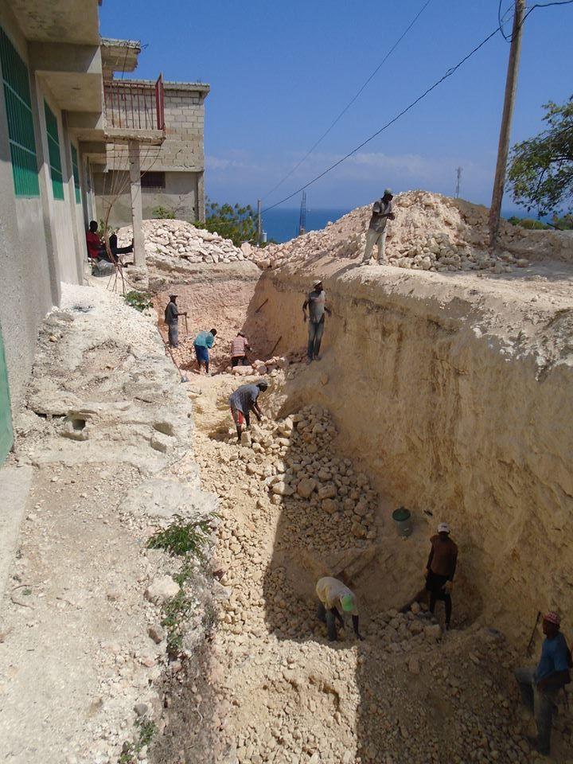 The large new cistern. 20’x20’x40’
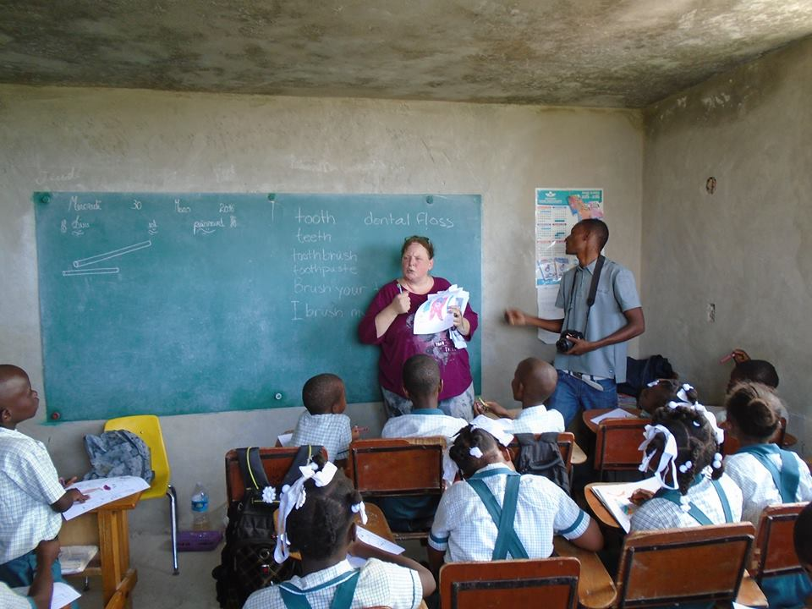
Working with the kids.
One of the most exciting things about the trip was the growing sense of partnership with the school, working with the teachers so that their skills are enhanced and the children benefit year round from their teaching. A week visit is a good thing, but the long term impact occurs mostly through the Haitian teachers in the school and the Haitian nurses in the clinic. The majority of their salaries come from contributions given in the US on a regular basis. As the IOG receives a steady income, we can plan and hire and increase enrollment, so I am especially thankful for those who give regularly in support of the school and medical projects. Contributions are tax-deductible and can be sent to
IOG
PO Box 2346
Leesburg, VA 20177

June 16-24 I will be leading a team to Merger, Haiti, from St Paul UMC in Lusby and other churches. There is still room on this team if you would like to come along. We still need a medical person and have a variety of other projects. The big construction project will be the walls and roof of the new cistern. School will still be in session so we will also be working with the school children for the week. If you are interested in joining us, please contact me for more information. The cost is $700 plus airfare and whatever you can raise in support of the projects.

In His Service,
David Graves
Davidgraves1982@gmail.com
240 601 0218

